**AMAZON CLONE WEBPAGE**

A PROJECT REPORT

Submitted by

MOOSA SHAKEER

*in partial fulfillment for the award of the degree*

*of*

# BACHELOR OF TECHNOLOGY

**IN**

**COMPUTER SCIENCE AND ENGINEERING**



Lovely Professional University, Punjab

NOVEMBER 2024

# Lovely Professional University, Punjab

**BONAFIDE CERTIFICATE**

Certified that this project report “AMAZON CLONE WEBPAGE” is the bonafide work of “ MOOSA SHAKEER” who carried

out the project work under my supervision.

**SIGNATURE**

**SUPERVISOR**

Abstract:

The Amazon clone webpage features a user-friendly interface designed to provide a seamless shopping experience. Key elements include a prominent search bar for easy product search, navigation options like "Today's Deals," "Customer Service," "Registry," "Gift Cards," and "Sell." Users can sign in to their accounts, view returns and orders, and access their shopping cart. The main banner promotes seasonal or special offers, and below it, product categories such as “Clothes,” “Health & Personal Care,” “Furniture,” “Electronics,” “Beauty picks,” “Pet Care,” “New Arrivals In Toys,” and “Discover Fashion Trends” are displayed to aid easy browsing. Additionally, localized shopping options are available, ensuring that users can switch between Amazon domains, such as [amazon.com](https://amazon.com/?form=MG0AV3) and Amazon India. The design is responsive, ensuring optimal performance across devices.

TABLE OF CONTENTS

|  |  |  |
| --- | --- | --- |
| CHAPTER  NO. | CHAPTER NAME | PAGE NO. |
| 1 | Title Page | i |
| 2 | Bonafide Certificate | ii |
| 3 | Abstract | iii |
| 4 | Chapter 1 | 6 |
| 5 | Chapter 2 | 7 - 8 |
| 6 | Chapter 3 | 9 - 13 |
| 7 | Chapter 4 | 14 - 20 |
| 9 | Chapter 5 | 21 - 49 |
| 10 | Chapter 6 | 50 - 51 |
| 11 | APPENDICES | 52 |
| 12 | REFERENCES | 53 |

LIST OF FIGURES

|  |  |  |
| --- | --- | --- |
| SR.NO | Detail | PAGE. NO |
| 1 | Web Interface Fig (1 - 9) | 9 - 13 |
| 2 | HTML Fig (1-3) | 18 - 19 |
|  |  |  |

CHAPTER - 1

**Introduction To**

**"AMAZON CLONE WEBPAGE"**

An Amazon clone webpage replicates the key features and design elements of Amazon's website. The homepage typically includes a prominent search bar for finding products, a navigation menu for categories such as "Today's Deals" and "Customer Service," and user account options like "Sign In" and "Your Orders." It also features dynamic banners for promotions and sections displaying various product categories. This clone aims to provide a seamless shopping experience similar to that of Amazon, with a focus on user accessibility, product discovery, and efficient navigation.

CHAPTER - 2

Project Overview:

Purpose: This project aims to create a functional and visually appealing e-commerce website that mirrors the core functionalities of Amazon. The focus will be on delivering a smooth and intuitive user experience, robust backend operations, and a scalable architecture.

**Scope:**

**1. User Authentication and Management**

* **Features**: Registration, login, logout, and profile management.
* **Goal**: Ensure secure and seamless user experience.

**2. Homepage Development**

* **Features**: Dynamic banners, product showcases, and navigation menus.
* **Goal**: Provide a welcoming and intuitive starting point for users.

**3. Product Listings and Search**

* **Features**: Product categories, subcategories, and search functionality.
* **Goal**: Enable users to find and browse products efficiently.

**Key Sections:**

**1. Header**

* **Logo**: Displaying the Amazon logo or your clone's logo.
* **Navigation Menu**: Links to Home, Today's Deals, Customer Service, Registry, Gift Cards, Sell.
* **Search Bar**: For finding products easily.
* **User Account**: Sign-in options, account details, and order history.
* **Cart**: Shopping cart with item count.

**2. Main Banner**

* **Promotions**: Dynamic banners showcasing seasonal offers, sales, or new arrivals.

**3. Product Categories**

* **Category Links**: Quick access to popular categories like Electronics, Clothing, Home & Kitchen, etc.
* **Featured Categories**: Highlights of trending or popular product categories.

**4. Featured Products**

* **Deals of the Day**: Highlighting special offers and discounts.
* **Top Picks**: Featured and recommended products based on user behavior.

**Outcome:**

The outcome of your Amazon clone webpage project will result in a fully functional, comprehensive e-commerce platform that mimics the key features and functionalities of Amazon.

CHAPTER - 3

**Screen Shots OFF Web Page**

Welcome to our Amazon clone interface: a sleek, intuitive homepage crafted with HTML and styled beautifully with CSS, offering seamless navigation and a dynamic user experience.

**Web Interface Fig -1**

Amazon clone webpage interface: a sleek, intuitive homepage crafted with HTML and styled beautifully with CSS, offering seamless navigation and a dynamic user experience.

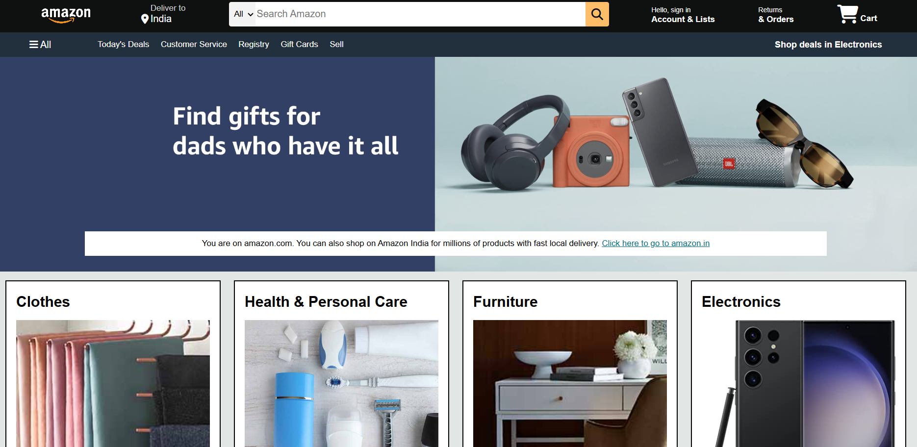

Web Interface Fig-2

Second figure showcases the founders cum chief chefs of the restaurant who decides the recipes and such.

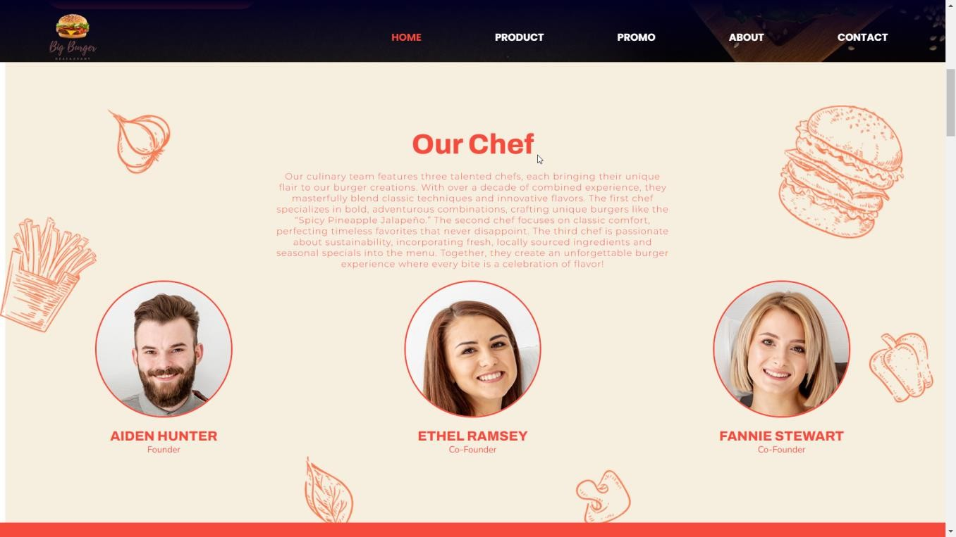

Web Interface Fig- 3

This section promotes the signature menu item.

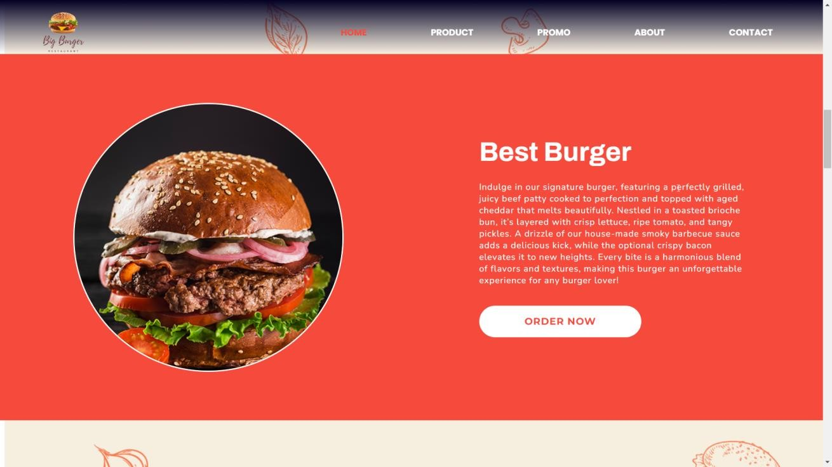

Web Interface Fig - 4

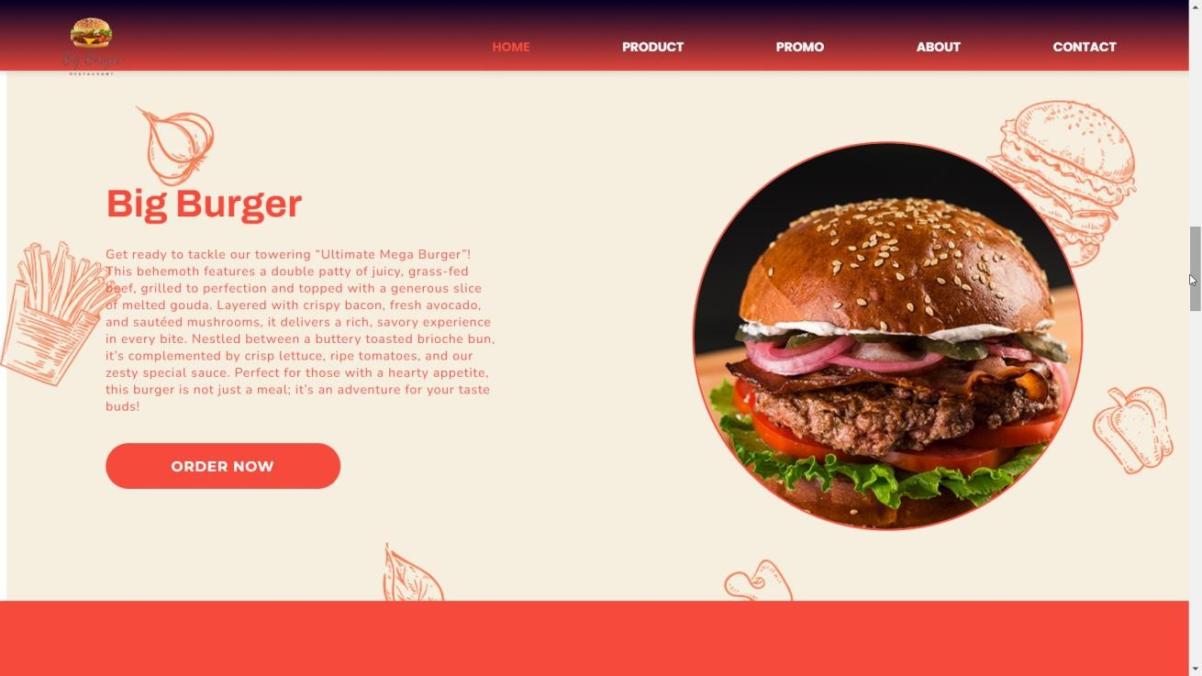

Web Interface Fig – 5

Section shows the statistics about the customers and outlets

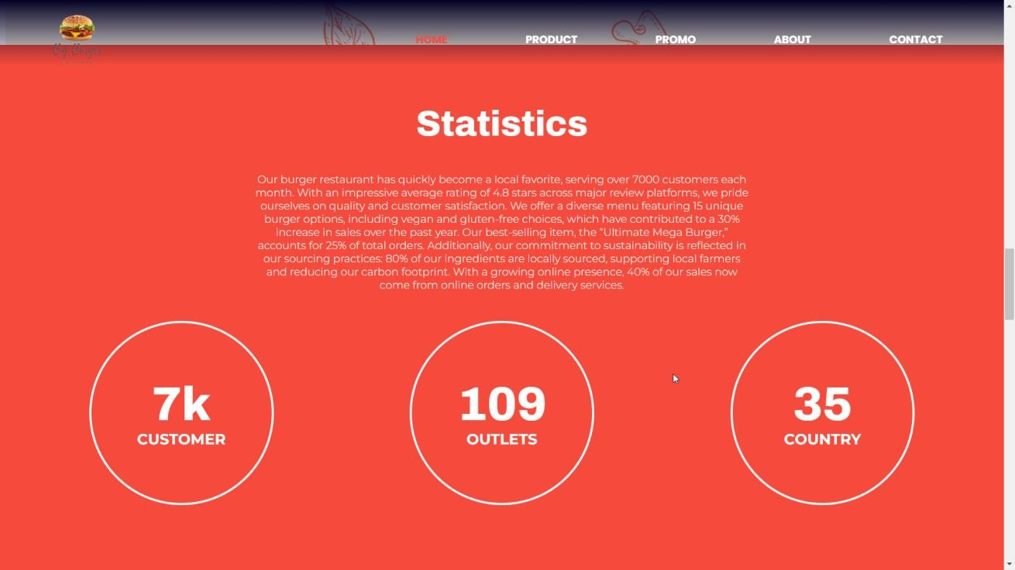

Web Interface Fig – 6

Details of the popular packages and prices.

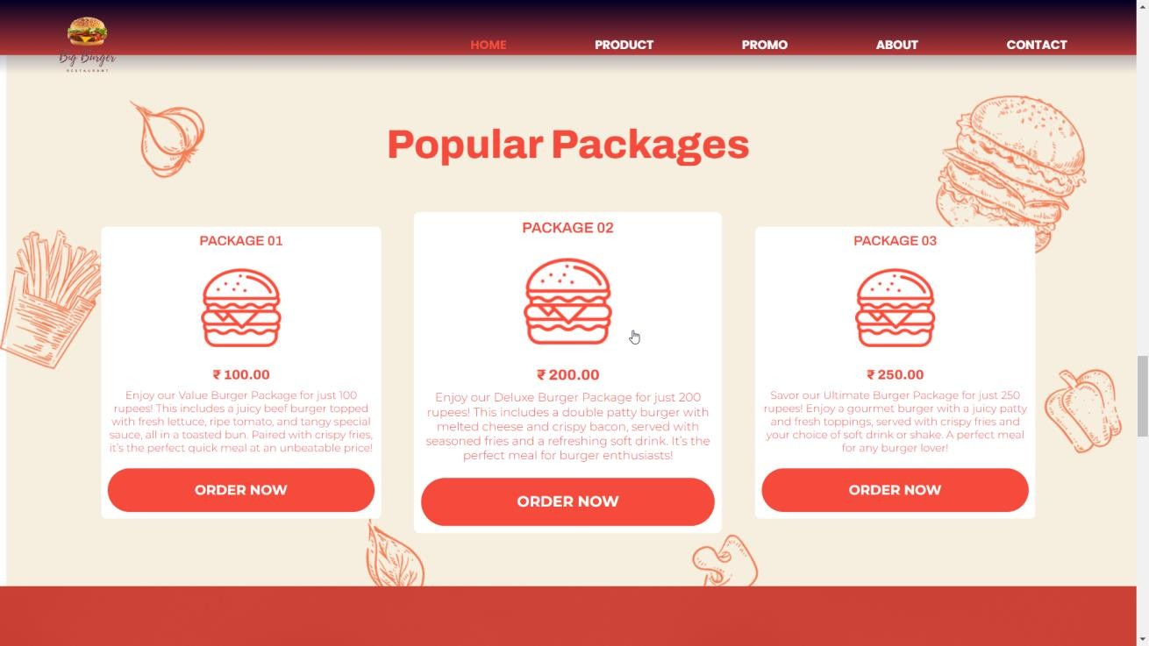

Web Interface Fig – 7

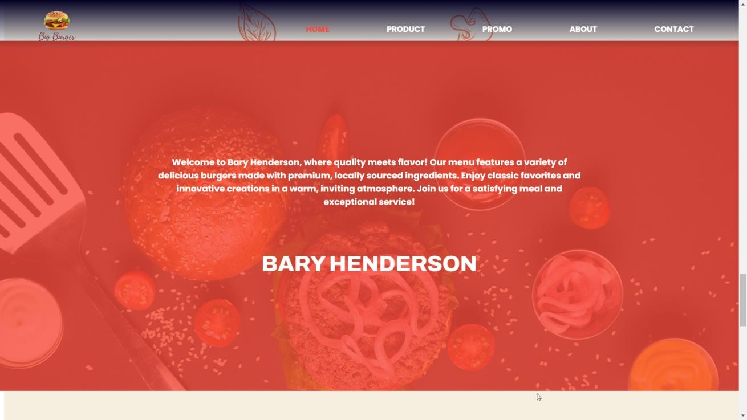

Web Interface Fig – 8

Section where customer can subscribe using their mail ID.

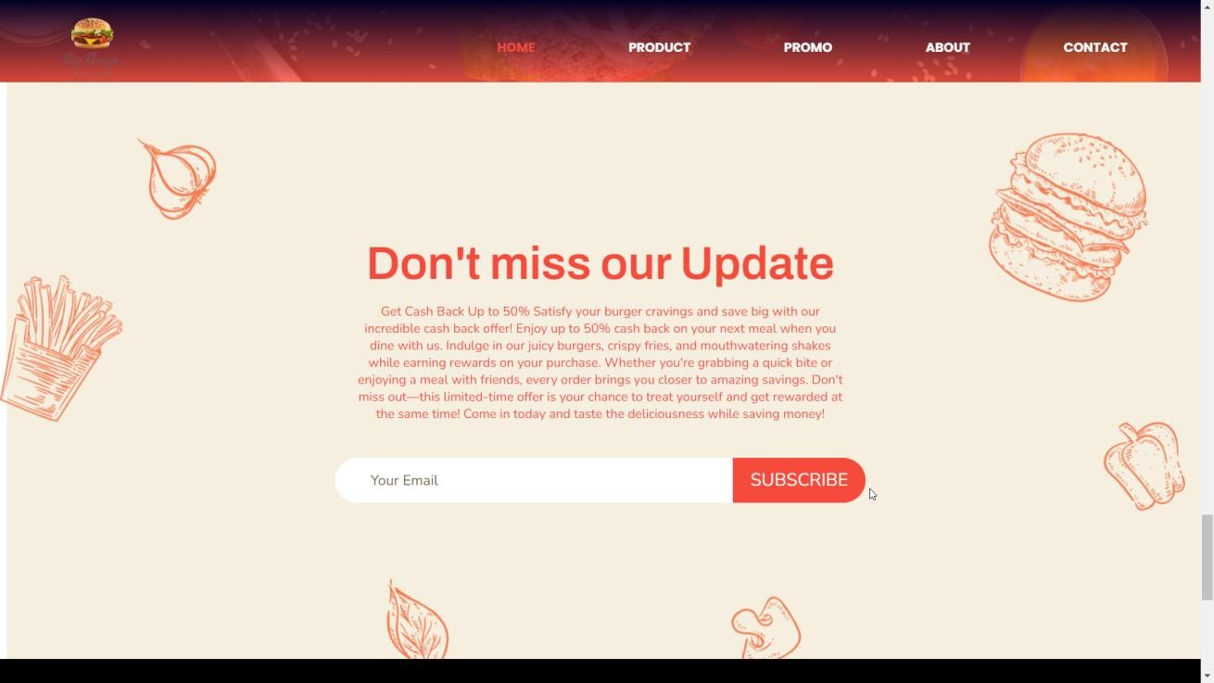

Web Interface Fig – 9

Footer where all information for contacts and copyrights are present.

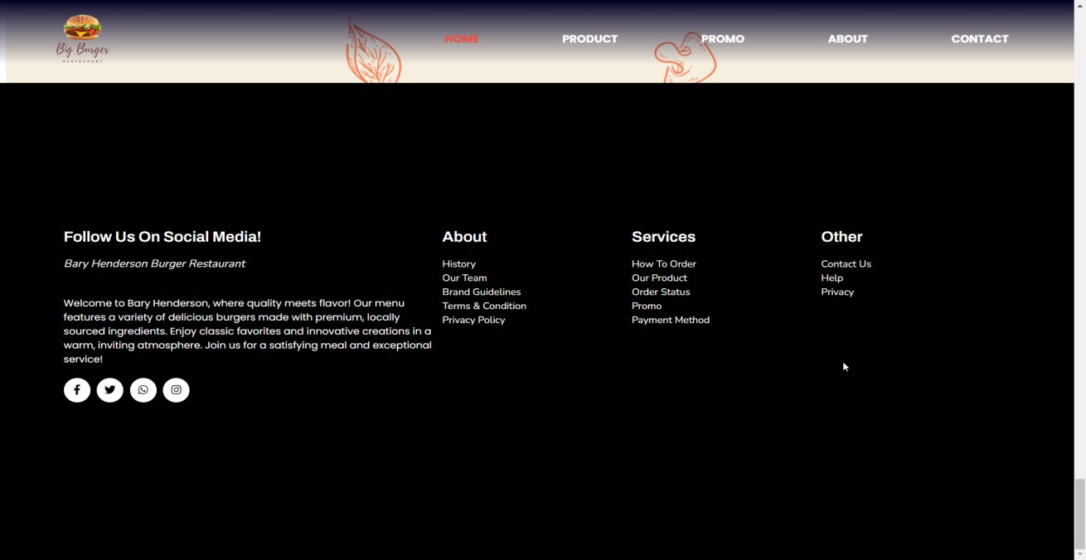

CHAPTER – 4

HTML – CODE

<!DOCTYPE html>

<html lang="en">

<head>

<meta charset="UTF-8">

<meta http-equiv="X-UA-Compatible" content="IE=edge">

<meta name="viewport" content="width=device-width, initial-scale=1.0">

<title>Burger Restaurant</title>

<link rel="icon" type="image/x-icon" href="images/logo.png">

<!-- LINK CSS FILE -->

<link rel="stylesheet" href="style.css">

<!-- FONT AWESOME LINK -->

<link rel="stylesheet" href="https://cdnjs.cloudflare.com/ajax/libs/font-awesome/6.2.1/css/all.min.css">

</head>

<body>

<!-- NAVBAR SECTION -->

<section class="navbar"> <div class="wrapper">

<!-- LOGO IMAGE -->

<img src="logo.png" alt="" class="logo">

<!-- NAVBAR LINKS -->

<ul class="navbarLinks" id="navbarLinks">

<li><a href="#home" class="navbarItem active">Home</a></li>

<li><a href="#product" class="navbarItem">Product</a></li>

<li><a href="#promo" class="navbarItem">Promo</a></li>

<li><a href="#about" class="navbarItem">About</a></li>

<li><a href="#contact" class="navbarItem">Contact</a></li>

</ul>

<i class="fa-solid fa-bars" id="menuBar"></i>

</div> </section>

<!-- HERO SECTION -->

<section class="hero" id="home">

<div class="wrapper">

<h1>Get Cashback <br> up to 50%</h1>

<p>Get Cash Back Up to 50%

Satisfy your burger cravings and save big with our incredible cash back offer! Enjoy up to 50% cash back on your next meal when you dine with us. Indulge in our juicy burgers, crispy fries, and mouthwatering shakes while earning rewards on your purchase.

Whether you're grabbing a quick bite or enjoying a meal with friends, every order brings you closer to amazing savings. Don't miss out—this limited-time offer is your chance to treat yourself and get rewarded at the same time! Come in today and taste the deliciousness while saving money!</p>

<a href="#" class="orderNowBtn">order now</a> </div> </section>

<!--OUR CHIEF SECTION -->

<section class="ourChief" id="about">

<div class="wrapper">

<h1 class="mainTitle">our chef</h1>

<p class="mainContent">Our culinary team features three talented chefs, each bringing their unique flair to our burger

creations. With over a decade of combined experience, they masterfully blend classic techniques and innovative flavors.

The first chef specializes in bold, adventurous combinations, crafting unique burgers like the “Spicy Pineapple Jalapeño.” The second chef focuses on classic comfort, perfecting timeless favorites that never disappoint. The third chef is passionate about sustainability, incorporating fresh, locally sourced ingredients and seasonal specials into the menu.

Together, they create an unforgettable burger experience where every bite is a celebration of flavor!

</p>

<div class="chefs">

<div class="chefCard">

<img src="chefImage01.png" alt="">

<h1>aiden hunter</h1>

<p>founder</p>

</div>

<div class="chefCard">

<img src="chefImage02.png" alt="">

<h1>Ethel Ramsey</h1>

<p>Co-Founder</p>

</div>

<div class="chefCard">

<img src="chefImage03.png" alt="">

<h1>Fannie Stewart</h1>

<p>Co-Founder</p>

</div>

</div>

</div> </section>

<!-- BEST BURGER SECTION -->

<section class="bestBurger" id="promo">

<div class="wrapper">

<img src="bestBurgerImg.png" alt="">

<div class="bestBurgerCard">

<h1>best burger</h1>

<p>Indulge in our signature burger, featuring a perfectly grilled, juicy beef patty cooked to perfection and topped with aged cheddar that melts beautifully. Nestled in a toasted brioche bun, it’s layered with crisp lettuce, ripe tomato, and tangy pickles. A drizzle of our house-made smoky barbecue sauce adds a delicious kick, while the optional crispy bacon elevates it to new heights. Every bite is a harmonious blend of flavors and textures, making this burger an unforgettable experience for any burger lover!</p>

<a href="#">order now</a>

</div>

</div> </section>

<!-- BIG BURGER SECTION -->

<section class="bigBurger">

<div class="wrapper">

<img src="bigBurgerImg.png" alt="">

<div class="bigBurgerCard">

<h1>big burger</h1>

<p>Get ready to tackle our towering “Ultimate Mega Burger”! This behemoth features a double patty of juicy, grassfed beef, grilled to perfection and topped with a generous slice of melted gouda. Layered with crispy bacon, fresh avocado, and sautéed mushrooms, it delivers a rich, savory experience in every bite. Nestled between a buttery toasted brioche bun, it’s complemented by crisp lettuce, ripe tomatoes, and our zesty special sauce. Perfect for those with a hearty appetite, this burger is not just a meal; it’s an adventure for your taste buds!</p>

<a href="#">order now</a>

</div>

</div> </section>

<!-- STATISTICS SECTION -->

<section class="statistics" >

<div class="wrapper" id="statistics">

<h1 class="statisticsMainTitle">Statistics</h1>

<p>Our burger restaurant has quickly become a local favorite, serving over 7000 customers each month. With an impressive average rating of 4.8 stars across major review platforms, we pride ourselves on quality and customer satisfaction.

We offer a diverse menu featuring 15 unique burger options, including vegan and gluten-free choices, which have contributed to a 30% increase in sales over the past year. Our best-selling item, the “Ultimate Mega Burger,” accounts for 25% of total orders.

Additionally, our commitment to sustainability is reflected in our sourcing practices: 80% of our ingredients are locally sourced, supporting local farmers and reducing our carbon footprint. With a growing online presence, 40% of our sales now come from online orders and delivery services.

</p>

<div class="statisticsCounters">

<div class="statisticsCounterCard">

<div class="counterK">

<h1 class="counterNumber" data-goal="7" id="counter01">0</h1>

<span id="counterSpan">k</span>

</div>

<h3>customer</h3>

</div>

<div class="statisticsCounterCard">

<h1 class="counterNumber" data-goal="109">0</h1>

<h3>outlets</h3>

</div>

<div class="statisticsCounterCard">

<h1 class="counterNumber" data-goal="35">0</h1>

<h3>country</h3>

</div>

</div>

</div> </section>

<!-- POPULAR PACKAGES SECTION -->

<section class="popularPackages" id="product">

<div class="wrapper">

<h1 class="mainTitle">popular packages</h1>

<div class="packages">

<div class="packageCard">

<h1>package 01</h1>

<img src="burgerIcon.png" alt="">

<h3> &#8377 100.00</h3>

<p>Enjoy our Value Burger Package for just 100 rupees! This includes a juicy beef burger topped with fresh lettuce, ripe tomato, and tangy special sauce, all in a toasted bun. Paired with crispy fries, it’s the perfect quick meal at an unbeatable price!

</p>

<a href="#">order now</a>

</div>

<div class="packageCard">

<h1>package 02</h1>

<img src="burgerIcon.png" alt="">

<h3> &#8377 200.00</h3>

<p>Enjoy our Deluxe Burger Package for just 200 rupees! This includes a double patty burger with melted cheese and crispy bacon, served with seasoned fries and a refreshing soft drink. It’s the perfect meal for burger enthusiasts!</p> <a href="#">order now</a>

</div>

<div class="packageCard">

<h1>package 03</h1>

<img src="burgerIcon.png" alt="">

<h3> &#8377 250.00</h3>

<p>Savor our Ultimate Burger Package for just 250 rupees! Enjoy a gourmet burger with a juicy patty and fresh

toppings, served with crispy fries and your choice of soft drink or shake. A perfect meal for any burger lover!

</p>

<a href="#">order now</a>

</div>

</div>

</div>

</section>

<!-- BARY HENDERSON SECTION -->

<section class="baryHenderson">

<div class="wrapper">

<p>Welcome to Bary Henderson, where quality meets flavor! Our menu features a variety of delicious burgers made with premium, locally sourced ingredients. Enjoy classic favorites and innovative creations in a warm, inviting atmosphere. Join us for a satisfying meal and exceptional service!

</p>

<h1>bary henderson</h1>

</div> </section>

<!-- SUBSCRIBE SECTION -->

<section class="subscribe" id="contact">

<div class="wrapper">

<h1>Don't miss our Update</h1> <p>Get Cash Back Up to 50%

Satisfy your burger cravings and save big with our incredible cash back offer! Enjoy up to 50% cash back on your next meal when you dine with us. Indulge in our juicy burgers, crispy fries, and mouthwatering shakes while earning rewards on your purchase.

Whether you're grabbing a quick bite or enjoying a meal with friends, every order brings you closer to amazing savings. Don't miss out—this limited-time offer is your chance to treat yourself and get rewarded at the same time! Come in today and taste the deliciousness while saving money!

</p>

<div class="subscribeBox">

<input type="search" placeholder="your email">

<a href="#">subscribe</a>

</div>

</div> </section>

<!-- FOOTER SECTION -->

<section class="footer">

<div class="wrapper">

<div class="col">

<h1>Follow Us on Social Media!</h1>

<i><h2><p>Bary Henderson Burger Restaurant<br></p></h2></i>

<br>

Welcome to Bary Henderson,

where quality meets flavor! Our menu features a variety of delicious burgers made with premium, locally sourced

ingredients. Enjoy classic favorites and innovative creations in a warm, inviting atmosphere. Join us for a satisfying meal and exceptional service!</p>

<div class="socialLinks">

<a href="https://www.facebook.com"><i class="fa-brands fa-facebook-f"></i></a>

<i class="fa-brands fa-twitter"></i>

<i class="fa-brands fa-whatsapp"></i>

<a href='https://www.instagram.com/'><i class="fa-brands fa-instagram"></i></a>

</div>

</div>

<div class="col">

<h1>about</h1>

<ul>

<li><a href="#">history</a></li>

<li><a href="#">our team</a></li>

<li><a href="#">brand guidelines</a></li>

<li><a href="#">terms & condition</a></li>

<li><a href="#">privacy policy</a></li>

</ul>

</div>

<div class="col">

<h1>services</h1>

<ul>

<li><a href="#">How to Order</a></li>

<li><a href="#">Our Product</a></li>

<li><a href="#">Order Status</a></li>

<li><a href="#">Promo</a></li>

<li><a href="#">Payment Method</a></li>

</ul>

</div>

<div class="col">

<h1>other</h1>

<ul>

<li><a href="#">Contact Us</a></li>

<li><a href="#">Help</a></li>

<li><a href="#">Privacy</a></li>

</ul>

</div>

</div>

</section>

<!-- JAVA SCRIPT LINK -->

<script src="script.js"></script>

</body> </html>

HTML Fig – 1

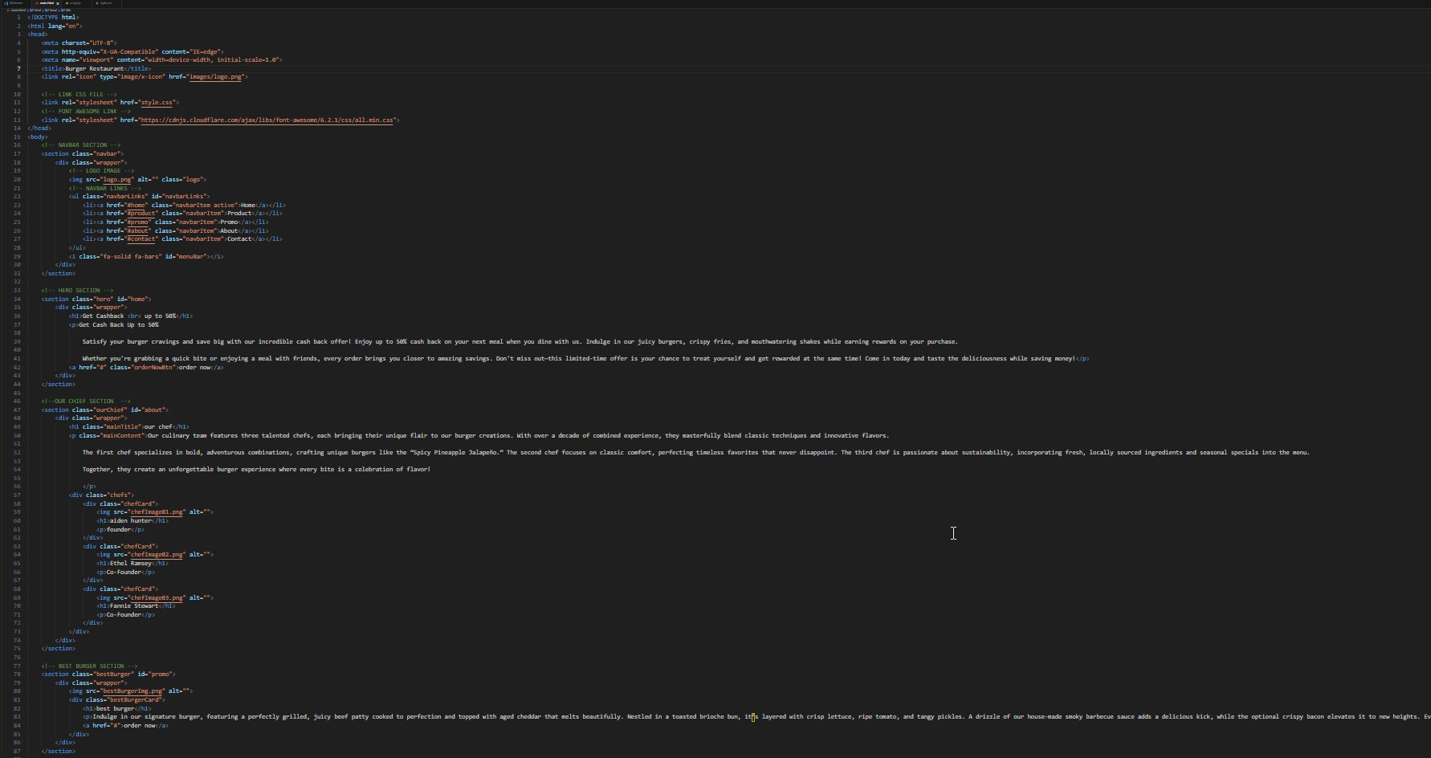

HTML Fig – 2

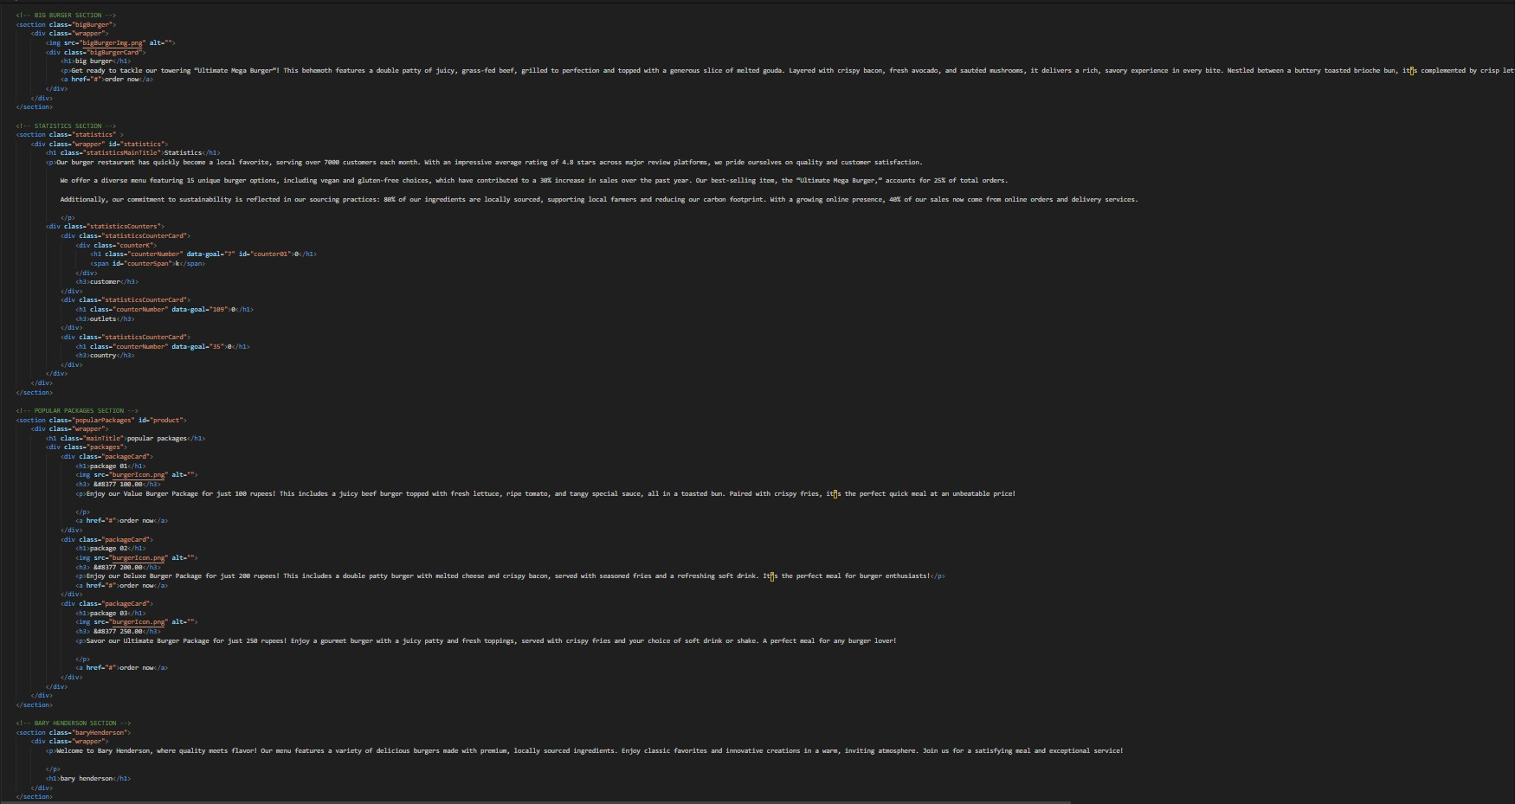

HTML Fig – 3

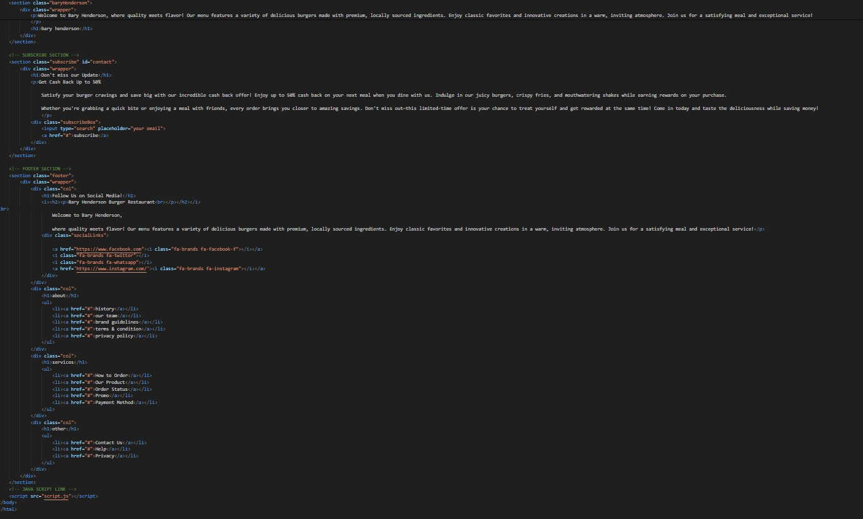

CHAPTER –

5

CSS – CODE

@import

url('https://fonts.googleapis.com/css2?family=Archivo:wght@200;300;400;500;600;700;800;900 &family=Montserrat:wght@300;700&family=Nunito&family=Poppins:wght@300;400;500;700&di splay=swap');

*{ margin: 0; padding: 0; text-decoration: none; box-sizing: border-box; font-family: 'Poppins', sans-serif;

}

body{

scroll-behavior: smooth;

}

/* HEADER STYLE START */

.navbar{ width: 100%;

height: 110px;

background: rgb(2,0,36); background: linear-gradient(180deg, rgba(2,0,36,1) 0%, rgba(0,212,255,0) 100%);

position: fixed; top: 0; z-index: 999;

}

.navbar .wrapper{

padding: 20px 103px 20px 83px;

width: 100%; display: flex; align-items: center; justify-content: space-between;

position: relative;

}

.navbar .wrapper img{

width: 93px;

}

.navbarLinks{

display: flex; align-items: center; justify-content: space-between; width: 59%; list-style: none;

}

.navbarLinks.vertical{

display: flex; flex-direction: column; align-items: center; position: absolute; top: 110px; width: 78%; list-style: none; background-color: rgba(0, 0, 0, 0.7); transition: all 0.3s ease-in-out;

}

.navbarLinks.vertical li { padding: 10px; border-bottom: 1px solid #fff; width: 100%; height: 100%; text-align: center;

}

.navbarItem{

color: #fff; font-size: 18px; font-weight: 800; text-transform: uppercase; transition: all 0.3s ease-in-out;

}

.navbarItem:hover, .navbarItem.active, .navbar .wrapper i:hover{

color: #f64b3c;

}

.navbar .wrapper i{

color: #fff; font-size: 18px; cursor: pointer; display: none; transition: all 0.3s ease-in-out;

}

/* HEADER STYLE END */

/* HERO SECTION STYLE START */

.hero { width: 100%; height: 100%; background-image: url('heroBackground.png'); background-position: center; background-repeat: no-repeat; background-size: cover;

}

.hero .wrapper{ height: 100%; margin: 0 103px 0 83px;

display: flex; flex-direction: column; justify-content: center;

}

.hero .wrapper h1{ margin: 160px 0 42px 0;

color: #fff; font-family: 'Archivo', sans-serif; font-size: 80px;

}

.hero .wrapper p { width: 45%;

color: #fff; font-size: 25px; font-weight: 300; letter-spacing: 1px; margin-bottom: 57px;

font-family: 'Nunito', sans-serif;

}

.hero .wrapper a{ width: 25%; display: flex; justify-content: center; align-items: center; text-align: center; height: 56px; background-color: #f64b3c;

color: #fff;

border-radius: 40px; text-transform: uppercase; font-weight: 700; margin-bottom: 95px; font-family: 'Montserrat', sans-serif;

}

.hero .wrapper a:hover{

color: #f64b3c; background: transparent; border: 1px solid #f64b3c;

}

/* HERO SECTION STYLE END */

/* OUR CHIEF SECTION STYLE START */

.ourChief{ height: 100%; width: 100%; background-image: url('ourChiefBackground.png'); background-position: center; background-repeat: no-repeat; background-size: cover;

}

.ourChief .wrapper{ padding: 120px 170px; width: 100%; height: 100%;

display: flex; flex-direction: column; align-items: center; justify-content: space-between;

}

.ourChief .wrapper .mainTitle { font-family: 'Archivo', sans-serif; text-transform: capitalize; font-weight: 800; font-size: 50px; color: #f64b3c; margin-bottom: 20px;

}

.ourChief .wrapper .mainContent{

width: 52%; text-align: center; color: #f64b3c; font-family: 'Montserrat', sans-serif; font-weight: 300; letter-spacing: 1px;

}

.chefs{ width: 100%; height: 60%;

display: flex;

align-items: center; justify-content: space-between;

}

.chefCard{ height: 100%;

display: flex; flex-direction: column; align-items: center; justify-content: space-around;

}

.chefCard img{ width: 245px; height: 245px; border-radius: 50%; transition: all 0.5s ease-in-out; cursor: pointer; border: 3px solid #f64b3c; margin: 20px 0;

}

.chefCard img:hover{

transform: scale(1.1);

}

.chefCard h1{

font-family: 'Archivo', sans-serif; font-weight: 800; text-transform: uppercase; color: #f64b3c;

}

.chefCard p{ color: #f64b3c; text-transform: capitalize; font-family: 'Nunito', sans-serif;

}

/* OUR CHIEF SECTION STYLE END */

/* BEST BURGER SECTION STYLE START */

.bestBurger{ width: 100%; height: 100%; background-color: #f64b3c;

display: flex; align-items: center; padding: 100px 0;

}

.bestBurger .wrapper{ width: 100%; height: 60%; margin: 0 150px ;

display: flex;

justify-content: space-between; align-items: center;

}

.bestBurger .wrapper img { height: 100%; width: 40%; border-radius: 50%; border: 3px solid #fff; cursor: pointer; transition: all 0.5s ease-in-out;

}

.bestBurger .wrapper img:hover{ transform: scale(1.1);

}

.bestBurgerCard { height: 100%; width: 40%;

display: flex; flex-direction: column; justify-content: center;

}

.bestBurgerCard h1 {

font-size: 55px; text-transform: capitalize;

color: #fff; font-family: 'Archivo', sans-serif;

}

.bestBurgerCard p { margin: 30px 0;

color: #fff; font-family: 'Nunito', sans-serif; letter-spacing: 1px; font-size: 18px;

}

.bestBurgerCard a { background-color: #fff; width: 60%; height: 65px; display: flex; align-items: center; justify-content: center; color: #f64b3c; font-family: 'Montserrat', sans-serif; font-weight: 700;

text-transform: uppercase; border-radius: 50px; font-size: 20px; letter-spacing: 1px; margin-top: 10px;

}

.bestBurgerCard a:hover{

color: #fff;

background: transparent;

border: 3px solid #fff;

}

/* BEST BURGER SECTION STYLE END */

/* BIG BURGER SECTION STYLE START */

.bigBurger{ height: 100%; width: 100%;

display: flex; align-items: center; padding: 100px 0; background-image: url('ourChiefBackground.png'); background-position: center; background-repeat: no-repeat; background-size: cover;

}

.bigBurger .wrapper{ width: 100%; height: 60%; margin: 0 150px ; display: flex; flex-direction: row-reverse; justify-content: space-between; align-items: center;

}

.bigBurger .wrapper img { height: 100%; width: 40%; border-radius: 50%; border: 3px solid #f64b3c; cursor: pointer; transition: all 0.5s ease-in-out;

}

.bigBurger .wrapper img:hover{

transform: scale(1.1);

}

.bigBurgerCard { height: 100%; width: 40%;

display: flex; flex-direction: column; justify-content: center;

}

.bigBurgerCard h1 {

font-size: 55px; text-transform: capitalize; color: #f64b3c; font-family: 'Archivo', sans-serif;

}

.bigBurgerCard p { margin: 30px 0; color: #f64b3c; font-family: 'Nunito', sans-serif; letter-spacing: 1px; font-size: 18px;

}

.bigBurgerCard a { background-color: #f64b3c; width: 60%; height: 65px; display: flex; align-items: center; justify-content: center;

color: #fff;

font-family: 'Montserrat', sans-serif; font-weight: 700; text-transform: uppercase; border-radius: 50px; font-size: 20px; letter-spacing: 1px; margin-top: 10px;

}

.bigBurgerCard a:hover{

color: #f64b3c; background: transparent; border: 3px solid #f64b3c;

}

/* BIG BURGER SECTION STYLE END */

/* STATISTICS SECTION STYLE START */

.statistics{

width: 100%;

height: 100%; background-color: #f64b3c;

}

.statistics .wrapper { padding: 100px 150px; width: 100%; height: 100%;

display: flex; flex-direction: column; align-items: center;

}

.statistics .wrapper .statisticsMainTitle {

color: #fff; font-family: 'Archivo', sans-serif; font-size: 60px; font-weight: 800; text-transform: capitalize; margin-bottom: 50px;

}

.statistics .wrapper p {

color: #fff;

font-family: 'Montserrat', sans-serif; width: 60%; font-size: 18px; text-align: center;

margin-bottom: 50px; font-weight: 300;

}

.statisticsCounters{

display: flex; height: 45%;

width: 100%;

align-items: center; justify-content: space-between; flex-wrap: wrap;

}

.statisticsCounterCard{ height: 310px; width: 310px; border-radius: 50%; border: 4px solid #fff; display: flex; flex-direction: column; align-items: center; justify-content: center; margin-bottom: 20px;

}

.counterK{

display: flex; align-items: center; justify-content: center;

}

.statisticsCounterCard h1 , .counterK span{

color: #fff; font-size: 80px; font-weight: 800; font-family: 'Archivo', sans-serif;

}

#counter01 , .counterK span{

display: flex; align-items: center; justify-content: center; height: 100%; width: 100%; margin: 0;

}

.statisticsCounterCard h3{

color: #fff; font-size: 25px; font-weight: 800; font-family: 'Montserrat', sans-serif; text-transform: uppercase;

}

/* STATISTICS SECTION STYLE END */

/* POPULAR PACKAGES SECTION STYLE START */

.popularPackages{ width: 100%; height: 100%; background-image: url(ourChiefBackground.png); background-position: center; background-size: cover; background-repeat: no-repeat;

}

.popularPackages .wrapper{ padding: 100px 150px; width: 100%; height: 100%;

display: flex; flex-direction: column; align-items: center;

}

.popularPackages .wrapper .mainTitle {

color: #f64b3c; font-family: 'Archivo', sans-serif; font-size: 60px; font-weight: 800; text-transform: capitalize; margin-bottom: 90px; width: 100%; text-align: center;

}

.packages{

display: flex;

width: 100%; height: 100%; align-items: center; justify-content: space-between; flex-wrap: wrap;

}

.packageCard{

height: 100%; width: 30%; background-color: #fff; border-radius: 8px;

display: flex; flex-direction: column; align-items: center; justify-content: space-between; padding: 10px; cursor: pointer; transition: all 0.4s ease-in-out;

}

.packageCard:hover{

transform: scale(1.1);

}

.packageCard h1{

font-size: 20px; font-weight: 600; text-transform: uppercase; font-family: 'Archivo', sans-serif; color: #f64b3c; width: 100%; text-align: center;

}

.packageCard h3{

font-family: 'Archivo', sans-serif; font-weight: 800; color: #f64b3c; font-size: 20px;

margin-bottom: 10px;

}

.packageCard img {

height: 30%; width: 30%; margin: 30px 0;

}

.packageCard p{

font-weight: 300; font-family: 'Montserrat', sans-serif; width: 100%; text-align: center; color: #f64b3c; margin-bottom: 20px;

}

.packageCard a{ width: 100%; padding: 20px;

display: flex; align-items: center; justify-content: center; background-color: #f64b3c; border-radius: 50px;

color: #fff;

font-family: 'Montserrat', sans-serif; font-weight: 800; font-size: 20px; text-transform: uppercase; transition: all 0.5s ease-in-out; text-align: center;

}

.packageCard a:hover{

color: #f64b3c; border: 2px solid #f64b3c; background: transparent;

}

/* POPULAR PACKAGES SECTION STYLE END */

/* BARY HENDERSON SECTION STYLE START */

.baryHenderson{

width: 100%; height: 800px;

background-image: url(baryHendersonBack.png); background-position: center; background-repeat: no-repeat; background-size: cover;

position: relative;

}

.baryHenderson::after{

position: absolute;

content: '';

width: 100%; height: 100%;

z-index: 9;

background-color: rgba(246, 75, 60, 0.8);

}

.baryHenderson .wrapper{

position: absolute; z-index: 99; top: 0;

padding: 100px 150px; width: 100%; height: 100%;

display: flex; flex-direction: column; align-items: center; justify-content: center;

}

.baryHenderson .wrapper p{

width: 70%; margin-bottom: 100px;

text-align: center; font-size: 20px; font-weight: 600;

color: #fff;

}

.baryHenderson .wrapper h1 {

color: #fff; font-family: 'Archivo', sans-serif; font-size: 50px; font-weight: 800; text-transform: uppercase;

}

/* BARY HENDERSON SECTION STYLE END */

/* SUBSCRIBE SECTION STYLE START */

.subscribe{ width: 100%; height: 100%; background: url(ourChiefBackground.png) no-repeat; background-position: center; background-size: cover; padding: 120px;

}

.subscribe .wrapper{ width: 100%; height: 100%; padding: 100px 150px;

display: flex; flex-direction: column; align-items: center; justify-content: center;

}

.subscribe .wrapper h1 {

font-size: 65px; font-weight: 600; color: #f64b3c; text-transform: none; width: 100%; text-align: center; font-family: 'Archivo', sans-serif; margin-bottom: 20px;

}

.subscribe .wrapper p {

font-size: 18px; font-weight: 300; font-family: 'Nunito', sans-serif; width: 100%; text-align: center; color: #f64b3c; max-width: 60%; margin-bottom: 50px;

}

.subscribeBox{ width: 65%; height: 63px; background-color: #fff; border-radius: 50px;

display: flex; align-items: center; overflow: hidden;

}

.subscribeBox input{ width: 75%; height: 100%; border: none; padding: 0 50px; outline: none; font-size: 20px; color: #835e3f; font-family: 'Nunito', sans-serif;

}

.subscribeBox input::placeholder{

color: #835e3f; text-transform: capitalize; font-size: 20px; font-family: 'Nunito', sans-serif;

}

.subscribeBox a{ width: 25%; height: 100%; background-color: #f64b3c;

color: #fff; display: flex; align-items: center; justify-content: center; font-size: 25px; text-transform: uppercase; font-family: 'Nunito', sans-serif; font-weight: 300; border-top-right-radius: 50px; border-bottom-right-radius: 50px; transition: all 0.4s ease-in-out;

}

.subscribeBox a:hover{

color: #f64b3c; background-color: #fff; border: 2px solid #f64b3c;

}

/* SUBSCRIBE SECTION STYLE END */ /* FOOTER SECTION STYLE START */

.footer{ width: 100%; height: 100%;

color: #fff;

background-color: #000; padding: 100px;

}

.footer .wrapper{ padding: 100px 0; width: 100%; height: 100%;

display: flex;

justify-content: space-between;

} .col{

padding: 50px 0; height: 100%;

display: flex; flex-direction: column;

}

.col:nth-of-type(1){ width: 40%;

}

.col:nth-of-type(2),.col:nth-of-type(3),.col:nth-of-type(4){ width: 20%;

}

.col h1 { font-family: 'Archivo', sans-serif; font-size: 25px; font-weight: 600; text-transform: capitalize; margin-bottom: 20px; width: 100%;

}

.col p { font-family: 'Nunito', sans-serif; width: 70%; font-size: 18px; font-weight: 300; text-transform: capitalize; margin-bottom: 20px;

}

.socialLinks{ width: 60%;

display: flex; flex-wrap: wrap; align-items: center;

}

.socialLinks i{ width: 42px; height: 42px; background-color: #fff; color: #000; border-radius: 50%; margin-right: 10px;

display: flex;

align-items: center; justify-content: center; font-size: 18px; cursor: pointer; transition: all 0.4s ease-in-out;

margin-bottom: 20px;

}

.socialLinks i:hover{ background: transparent; border: 1px solid #f64b3c; color: #f64b3c; transform: scale(1.08);

}

.col ul{ list-style: none;

} .col ul li a{ color: #fff; font-family: 'Nunito', sans-serif; transition: all 0.4s ease-in-out; text-transform: capitalize;

}

.col ul li a:hover{ color: #f64b3c;

}

/* FOOTER SECTION STYLE END */

/* RESPONSIVE MEDIA QUERIES */

@media screen and (max-width: 854px) {

.navbarLinks{ display: none;

}

.navbar .wrapper i{ display: block; .packages{

flex-direction: column;

}

.packageCard{ width: 100%; margin: 20px 0;

}

.baryHenderson .wrapper p, .baryHenderson .wrapper h1{

width: 100%; text-align: center;

}

}

@media screen and (max-width: 1148px) {

.bestBurger .wrapper{ flex-direction: column; align-items: center;

}

.bestBurger .wrapper img, .bigBurger .wrapper img {

margin: 26px; width: 100%;

}

.bestBurgerCard , .bigBurgerCard{

align-items: center; width: 100%;

}

.bigBurger .wrapper{ flex-direction: column-reverse; align-items: center;

}

.statisticsCounters{ flex-direction: column; align-items: center;

}

}

@media screen and (max-width: 1505px){

.subscribeBox a { font-size: 75%;

}

}

@media screen and (max-width: 1076px) {

.ourChief .wrapper h1,.statistics .wrapper h1{ margin-bottom: 20px;

}

.chefs{ flex-wrap: wrap; justify-content: center;

}

.chefCard{ margin: 10px;

}

.chefCard img{ margin: 20px 0;

}

.subscribeBox a, .subscribeBox input::placeholder , .subscribeBox input{

font-size: 10px;

}

.subscribeBox{ width: 100%; }

@media screen and (max-width: 670px) {

.hero .wrapper a , .bestBurgerCard a,.bigBurgerCard a{

font-size: 16px; width: 50%;

}

.hero .wrapper h1{

font-size: 55px; width: 100%;

}

.hero .wrapper p{ width: 100%;

}

.ourChief .wrapper,.statistics .wrapper,.popularPackages .wrapper{ padding: 100px 100px;

}

.ourChief .wrapper .mainTitle,.bestBurgerCard h1, .bigBurgerCard h1,.statistics .wrapper .statisticsMainTitle, .popularPackages .wrapper .mainTitle, .baryHenderson .wrapper h1{

font-size: 30px; text-align: center; width: 100%;

}

.ourChief .wrapper .mainContent,.bestBurgerCard p,.bigBurgerCard p,.statistics .wrapper p{

letter-spacing: normal; text-align: center; width: 100%;

}

.bestBurger .wrapper,.bigBurger .wrapper{

margin: 0 100px;

}

.statisticsCounterCard{

height: 215px; width: 215px;

}

.subscribe{ padding: 0;

}

.footer .wrapper{ flex-direction: column; width: 100%; align-items: center;

}

.footer .wrapper .col{ width: 100%; text-align: center;

}

.col p{

width: 100%; text-align: center;

}

.socialLinks{ width: 100%; justify-content: center;

}

}

@media screen and (max-width: 420px) { .baryHenderson .wrapper p{

width: 100%; font-size: 15px;

}

.baryHenderson .wrapper h1{ font-size: 18px;

.subscribe .wrapper{ padding: 100px 10px;

}

.bigBurger .wrapper a, .bestBurger .wrapper a{

text-align: center;

}

}

CHAPTER – 6

JavaScript CODE

const navbarLinks = document.getElementById('navbarLinks'); const menuBar = document.getElementById('menuBar'); const counter01 = document.getElementById('counter01'); const statisticsSection = document.getElementById('statistics'); //statistics section const statisticsSectionOffset = statisticsSection.offsetTop; const counterSpan = document.getElementById('counterSpan'); const counterNumber = document.querySelectorAll('.counterNumber'); var started = false;

window.onscroll = () => { var windowScrollingOffset = window.scrollY;

if(windowScrollingOffset >= statisticsSectionOffset){ if(!started){ counterNumber.forEach(element => {

counter(element);

});

}

started = true;

}

} counterSpan.style.display = 'none';

function counter(element){ var goal = element.dataset.goal; var count = setInterval(()=>{ element.innerText ++; counterSpan.style.display = 'block'; if(element.innerHtml == 0){ counterSpan.style.display = 'none'; } if(element.innerText == goal){ clearInterval(count);

}

}, 2000 / goal);

}

// MENU BAR CLICK

menuBar.onclick = function () { if(navbarLinks.className == 'navbarLinks'){ navbarLinks.className += ' vertical';

} else { navbarLinks.className = 'navbarLinks';

}};

JavaScript Fig – 1

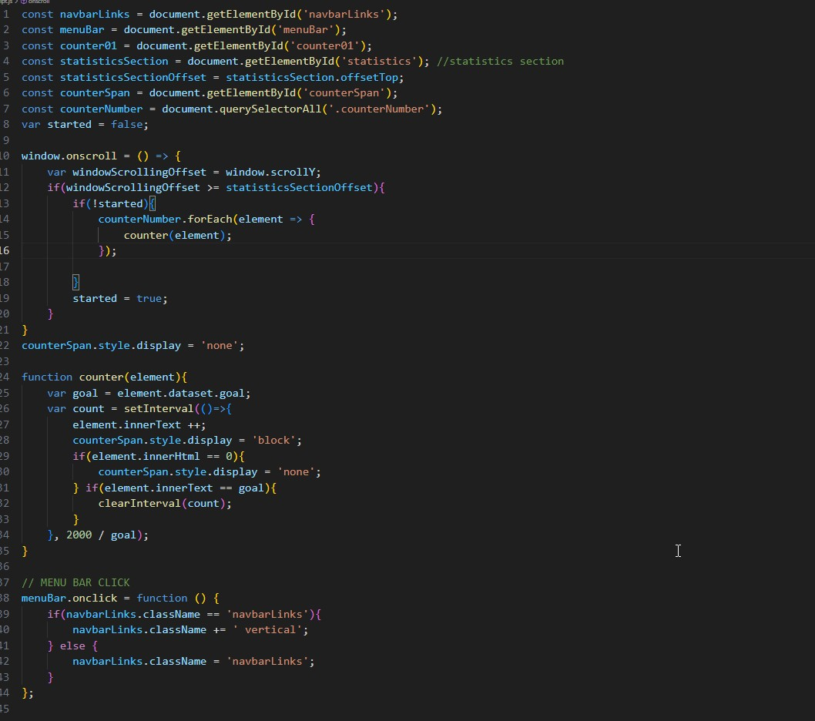

# APPENDICES

APPENDIX 1: PROJECT STRUCTURE

* **index.html** – The main homepage for the restaurant project.
* **style.css** – CSS file for styling the project. • **scripts.js** – JavaScript file to add interactivity to the site.

APPENDIX 2: TOOLS USED

* **HTML5** – For creating the structure of the web pages.
* **CSS3** – For styling the web pages and creating a visually appealing design. • **JavaScript** – For adding interactivity.

APPENDIX 3: DATA SOURCES

* **Sample Data** – The data was generated to simulate real restaurants.

No external data sources were used. • **Icons** – Icons were obtained from [FontAwesome.](https://fontawesome.com/)

# REFERENCES

1. Google. (n.d.). *Google search*. Retrieved October , 2024, from [https://www.google.com](https://www.google.com/)
2. OpenAI. (2024). *ChatGPT* [Large language model]. OpenAI. <https://chat.openai.com/>
3. Duckett, J. (2011). *HTML and CSS: Design and build websites*. Wiley.
4. GitHub. (2024). *GitHub repositories* [Code repository]. GitHub.

[https://www.github.com](https://www.github.com/)